Project - High Level Design
on
  - Dockerized Healthcare Python Flask Service
  - Course Name: DevOps Foundation

Institution Name: Medi-caps University – Datagami Skill Based Course

Student Name(s) & Enrolment Number(s):
Sr no | Student Name | Enrolment Number
1 | PRAKHAR JAIN | EN24CA5030122
2 | AAYUSH | EN22IT301004
3 | DANISH SHAIKH | EN22IT301032
4 | KOMOLIKA VYAS | EN24CA5030083
5 | KASHISH BILALA | EN24CA5030079

Group Name: Group 04D12
Project Number: DO-42
Industry Mentor Name: Vaibhav
University Mentor Name: Akshay Saxena
Academic Year:2025-2026

Table of Contents
- Introduction
  - Scope of the document.
  - Intended Audience
  - System overview.
- System Design.
  - Application Design
  - Process Flow.
  - Information Flow.
  - Components Design
  - Key Design Considerations
  - API Catalogue.
- Data Design.
  - Data Model
  - Data Access Mechanism
  - Data Retention Policies
  - Data Migration
- Interfaces
- State and Session Management
- Caching
- Non-Functional Requirements
  - Security Aspects
  - Performance Aspects
- References

1.Introduction
The Dockerized Healthcare Python Flask Service is a cloud-ready web application designed to manage healthcare-related operations such as patient records, appointment management, and medical data processing. The system is built using the Python Flask framework and is containerized using Docker to ensure portability, scalability, and consistent deployment across environments.
In modern healthcare systems, reliability, security, and scalability are critical requirements. By leveraging containerization, the application ensures environment consistency across development, testing, and production stages. docker enables the service to run in isolated containers, eliminating dependency conflicts and simplifying deployment processes.

1.1 Scope of the document
This document defines the High-Level Design (HLD) of the Dockerized Healthcare Python Flask Service. It provides an overview of the system architecture, major components, deployment strategy, and technology stack used to build and operate the application.
The scope of this document includes:
- Description of the overall system architecture and design approach
- Overview of the Python Flask-based REST API structure
- Containerization strategy using Docker
- Database integration (e.g., MySQL)
- CI/CD pipeline integration for automated build and deployment
- Deployment model (local, cloud, or container orchestration platforms)
- High-level security and scalability considerations

1.2 Intended Audience
This High-Level Design (HLD) document for the Dockerized Healthcare Python Flask Service is intended for stakeholders who require an understanding of the system’s architecture, design decisions, and deployment approach.
The intended audience includes:
- Software Developers – To understand the application structure, API design, and integration points.
- DevOps Engineers – To review the containerization strategy, CI/CD pipeline integration, and deployment architecture.
- System Architects – To evaluate architectural patterns, scalability, and technology choices.
- Project Managers – To gain insight into system scope, technical direction, and deployment model.
- Quality Assurance (QA) Engineers – To understand the system flow for designing test strategies.
- Stakeholders and Reviewers – To assess the overall technical feasibility and infrastructure design.

1.3 System overview
The system is developed using the Python Flask framework, which provides a lightweight and flexible REST API architecture. The application is packaged into Docker containers to ensure consistency across development, testing, and production environments. Containerization eliminates dependency conflicts and simplifies deployment.

High-Level Architecture Overview
At a high level, the system consists of the following components:
- Client Layer
  - Web browser or API client
  - Sends HTTP requests to the backend service

- Application Layer (Flask Service)
  - RESTful API built using Python Flask
  - Handles business logic and request processing
  - Communicates with the database

- Database Layer
  - MySQL database for storing patient records and healthcare data
  - Ensures data persistence and integrity

- Containerization Layer (Docker)
  - Application and database run in isolated containers
  - Ensures portability and environment consistency

5. CI/CD Integration
  - Automated build and test pipeline
  - Continuous deployment to target environments

Deployment Overview
The application can be deployed in:
- Local development environments
- Cloud platforms
- Container orchestration platforms such as Kubernetes.

2 . System Design
The system design describes the architectural structure, functional workflow, data movement, major components, and critical design considerations of the Dockerized Healthcare Python Flask Service.
The system follows a stateless design principle, making it suitable for horizontal scaling and container orchestration platforms. All communication between components occurs through well-defined interfaces, primarily using HTTP/HTTPS protocols and JSON data formats.

2.1 Application Design
The application follows a layered architecture pattern to ensure separation of concerns and maintainability.
Layers:
- Presentation Layer
    - RESTful API endpoints exposed via Flask
    - Accepts HTTP requests (GET, POST, PUT, DELETE)
- Business Logic Layer
  - Implements healthcare-related logic
  - Handles validations, data processing, and response formatting
- Data Access Layer
  - Interacts with MySQL database
  - Performs CRUD operations
- Containerization Layer
  - Docker container packages application and dependencies
  - Ensures environment consistency

The application is stateless, making it scalable and suitable for container orchestration platforms.

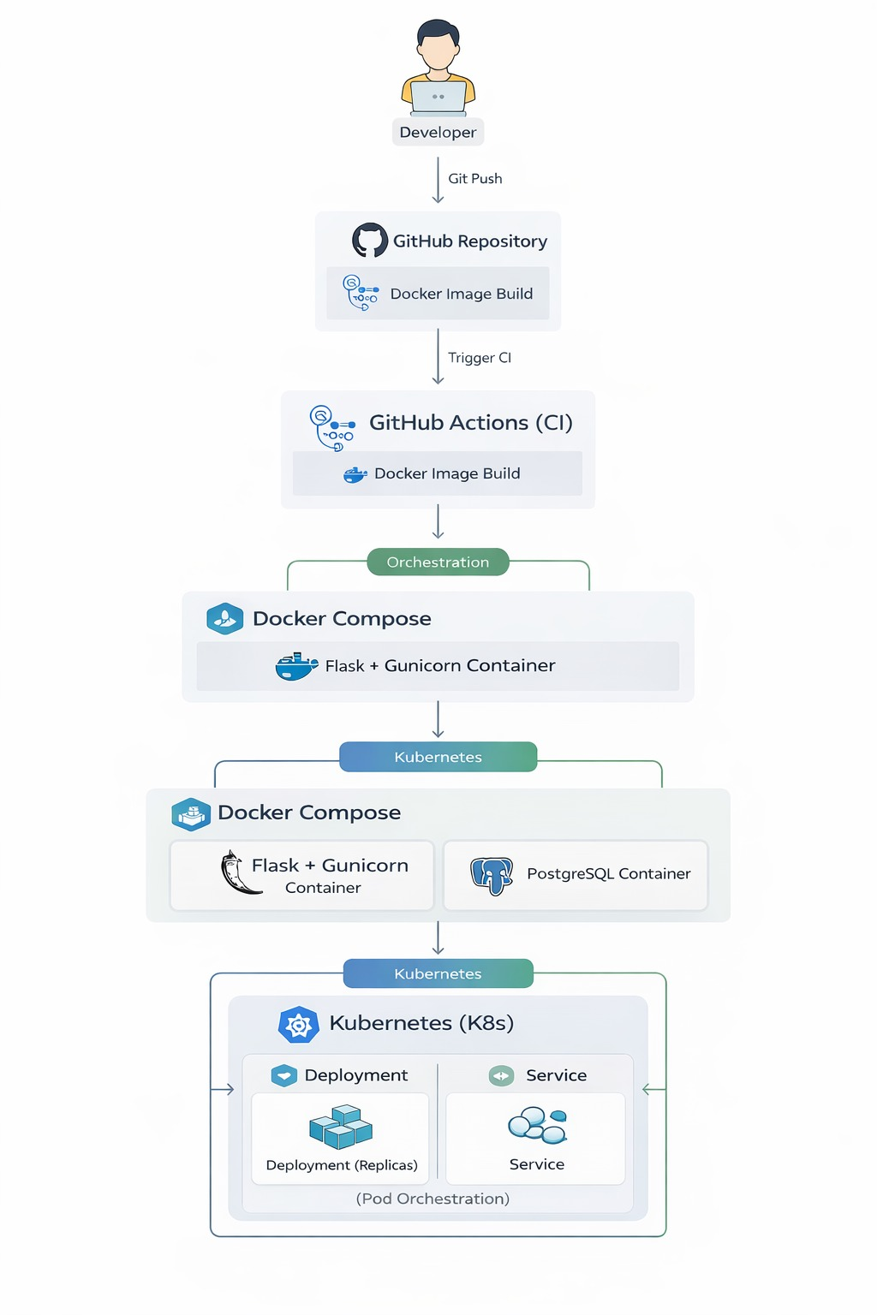

2.2 Process Flow

Below is the high-level request processing flow:
- User sends HTTP request (via browser/API client)
- Request reaches Flask REST API
- Input validation is performed
- Business logic is executed
- Database query is performed (if required)
- Response is generated (JSON format)
- Response sent back to client
Integrated with CI/CD:
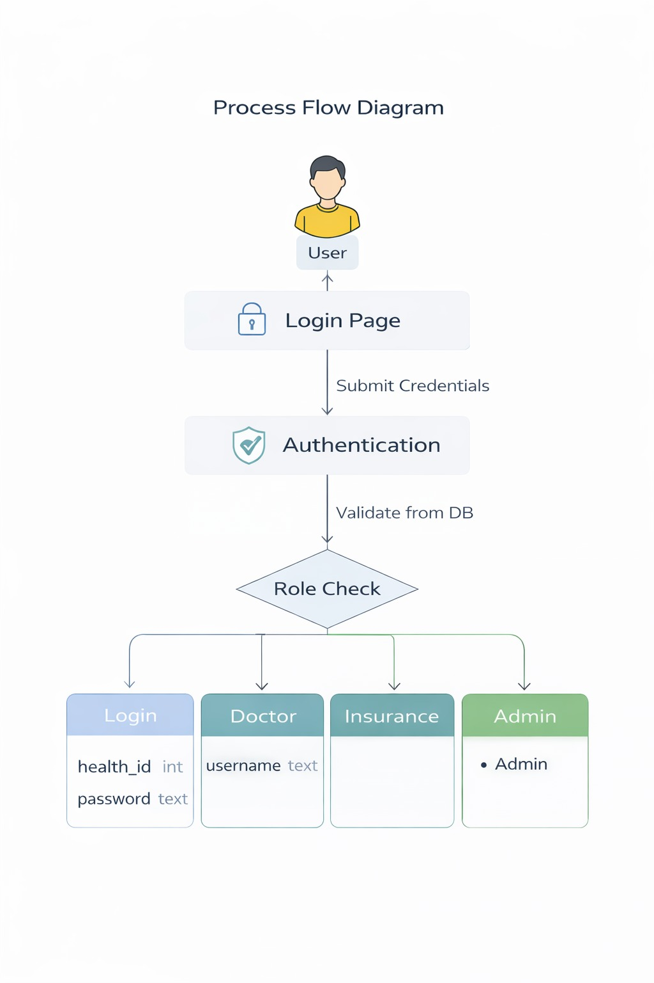
- Code commit → Automated build → Automated test → Docker image creation → Deployment
2.3 Information Flow
The information flow in the system follows this path:
Client → Flask API → Business Logic → Database → Flask API → Client
Data Types Managed:
- Patient information
- Appointment details
- Healthcare records
Key Characteristics:
- Data stored persistently in MySQL
- Communication via HTTP/HTTPS
- Data exchanged in JSON format
- Secure credential handling via environment variables
2.4 Components Design
The system consists of the following key components:
1. Web/API Component
- Built using Python Flask
- Exposes REST endpoints
- Handles request routing
2. Database Component
- MySQL database
- Stores structured healthcare data
- Ensures ACID compliance
3. Docker Component
- Dockerfile defines build configuration
- Docker container encapsulates runtime
- Optional Docker Compose for multi-container setup
4. CI/CD Component
- Automated build
- Automated test execution
- Docker image push
- Deployment automation

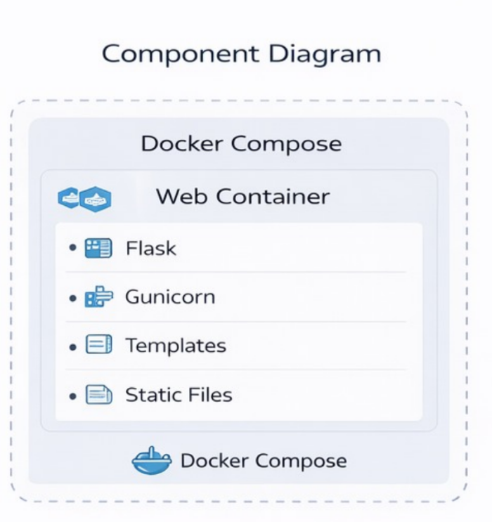
2.5 Key Design Considerations
The system is designed keeping the following considerations in mind:
1. Scalability
- Stateless API design
- Compatible with horizontal scaling
2. Security
- Input validation
- Secure database credentials
- HTTPS support (in production)
3. Reliability
- Container isolation
- Automated testing in CI pipeline
4. Maintainability
- Modular code structure
- Clear separation of layers
5. Portability
- Docker ensures consistent runtime environment
6. Performance
- Efficient database queries
- Lightweight Flask framework

2.6 API Catalogue
Below is a sample high-level API catalogue:
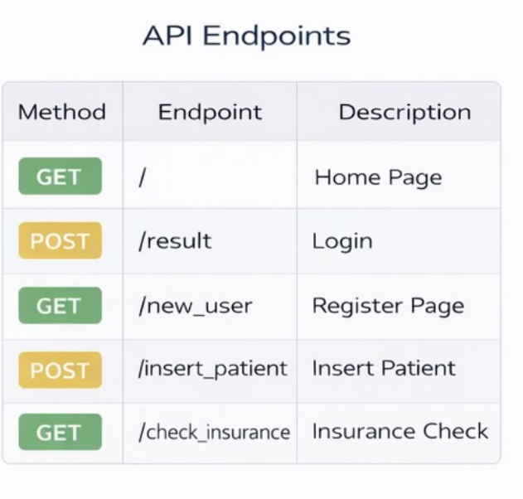

3. Data Design
The Data Design section describes how data is structured, stored, accessed, secured, retained, and migrated within the Dockerized Healthcare Python Flask Service. Since healthcare systems handle sensitive and structured information, the data architecture is designed to ensure integrity, security, scalability, and compliance readiness.

3.1 Data Model
The system uses a relational database model (MySQL) to manage structured healthcare data.
Core Entities:
- Patient
  - Patient_ID (Primary Key)
  - Name
  - Date_of_Birth
  - Gender
  - Contact Information
  - Address
  - Medical History Reference
- Appointment
  - Appointment_ID (Primary Key)
  - Patient_ID (Foreign Key)
  - Doctor_Name
  - Appointment_Date
  - Status
- Medical Record
  - Record_ID (Primary Key)
  - Patient_ID (Foreign Key)
  - Diagnosis
  - Prescription
  - Notes
  - Created_Timestamp
Relationships:
- One Patient → Many Appointments
- One Patient → Many Medical Records
The database schema ensures:
- Referential integrity using foreign keys
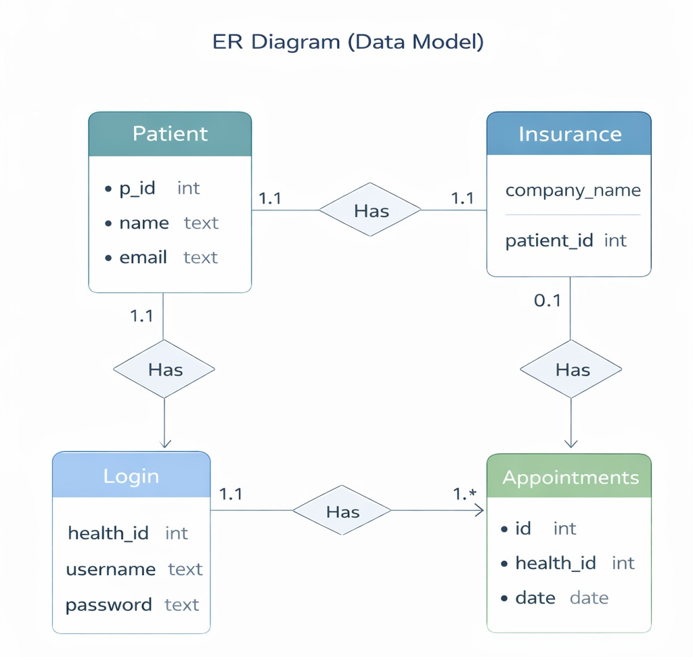
- Normalization to reduce redundancy.

3.2 Data Access Mechanism
The application accesses data through a structured data access layer within the Flask application.
Mechanism:
- REST API receives request
- Business logic layer processes validation
- Direct SQL queries interact with MySQL
- JSON response returned to client
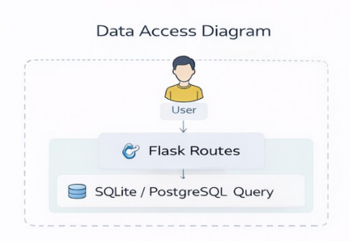

3.3 Data Retention Policies
Healthcare data requires careful retention and management policies.
Retention Strategy:
- Patient and medical records stored persistently in the database
- No automatic deletion of critical medical records
- Soft delete strategy (optional) for logical record removal
- Backup mechanism for disaster recovery
Backup & Recovery:
- Scheduled database backups
- Secure storage of backup files
- Recovery testing procedures
Retention policies may follow regulatory requirements depending on deployment region.

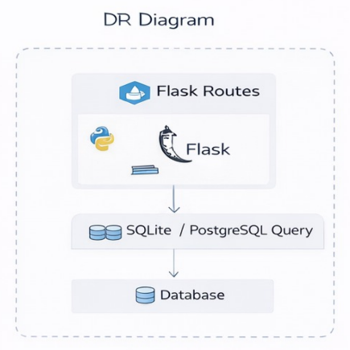

3.4 Data Migration
Data migration ensures smooth transition during system upgrades or environment changes.

Migration Scenarios:
- Schema updates (adding new fields/tables)
- Moving database from local to cloud
- Version upgrades
Migration Strategy:
- Use migration tools (e.g., Flask-Migrate / Alembic)
- Maintain version-controlled schema
- Backup before migration
- Validate data integrity post-migration
The migration process ensures minimal downtime and zero data loss during system upgrades or deployment changes.

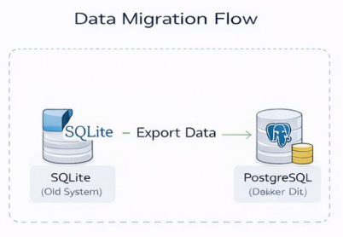

4. Interface
The Healthcare Management System provides a user-friendly web interface that allows patients, doctors, and administrators to interact with the system efficiently. The system is developed using a frontend user interface connected to a Flask-based backend server and database.

4.1 Login Interface
The login interface allows registered users (patients and doctors) to securely access the system by entering their email ID and password. Authentication is verified by the backend server before granting access to the dashboard. This ensures only authorized users can use the application.

4.2 Patient Registration Interface
The registration page enables new patients to create an account by entering personal details such as name, phone number, email address, age, and password. After successful registration, the patient can log in and access healthcare services.

4.3 Patient Dashboard Interface
After logging in, the patient is redirected to the dashboard. The dashboard provides navigation options such as booking an appointment, uploading medical reports, viewing reports, and checking appointment status. It acts as the central control panel for the patient.

4.4 Appointment and Scan Booking Interface
This interface allows patients to schedule medical appointments and diagnostic scans. The patient selects the doctor, date, and time slot. The information is stored in the database and is accessible to the doctor.
4.5Medical Report Interface Patients can upload their medical reports and also view previously uploaded reports. Doctors can access these reports for diagnosis and consultation. This reduces paperwork and helps maintain digital medical records.

4.6 Doctor Dashboard Interface
The doctor dashboard allows doctors to view patient appointments and reports. Doctors can review patient data and provide consultation based on the uploaded medical records.

5. State and Session Management
The Healthcare Management System is a web-based application developed using Flask. Since HTTP is a stateless protocol, the server does not automatically remember user information between requests.
Therefore, a session management mechanism is implemented to maintain user state after authentication.
5.1 User Authentication
When a patient or doctor logs into the system using a valid email and password, the credentials are verified by the backend server. After successful verification, the system creates a session for that user. The session uniquely identifies the logged-in user and stores essential information such as user ID and role (patient or doctor).
This prevents unauthorized users from accessing restricted pages such as the dashboard, appointment details, and medical reports.

5.2 Session Creation
Flask session management is used to maintain the login state.
After login:
- A secure session ID is generated by the server.
- The session data is stored on the server side.
- A session cookie is sent to the user's browser.
For every request, the browser sends this session cookie back to the server, allowing the system to recognize the authenticated user without requiring login again.

5.3 Maintaining User State
The system checks the session before allowing access to protected pages such as:
- Patient Dashboard
- Appointment & Scan Booking
- Report Upload and Viewing
- Doctor Dashboard
If the session exists, access is granted. If the session does not exist, the user is redirected to the login page. This ensures that only authenticated users can access confidential healthcare data.
5.4 Session Expiration
For security reasons, sessions automatically expire after a certain period of inactivity. When the session expires:
The user is automatically logged out.
The user must log in again to access the system.
This prevents unauthorized access if the user leaves the system unattended.

5.5 Logout Mechanism
The system provides a logout option for both patients and doctors. When the user clicks logout:
- The session is destroyed on the server.
- The session cookie is removed from the browser.
- The user is redirected to the login page.

5.6 Security Measures

To improve security, the following practices are implemented:
- Password authentication before access
- Session-based authorization
- Restricted access to medical records
- Automatic session timeout
- Protection of patient data from unauthorized users

This session management mechanism ensures confidentiality, integrity, and secure access to healthcare information within the system.
6. Caching
Caching is implemented in the Healthcare Management System to improve performance and reduce the load on the backend server and database. Since the system is accessed frequently by patients and doctors to view dashboards, appointments, and medical reports, repeatedly fetching the same information from the database would slow down the application. Therefore, caching is used to temporarily store frequently accessed data.

6.1 Objective of Caching
The objective of caching in the system is to:
- Improve application speed
- Reduce database access time
- Minimize server processing
- Provide a smooth user experience

6.2 Caching Mechanism
When a user requests data (for example, opening the dashboard), the system follows the steps below:

- The frontend sends a request to the Flask backend.
- The backend first checks whether the requested data exists in cache memory.
- If the data exists (Cache Hit), it is directly returned to the user.
- If the data does not exist (Cache Miss), the system retrieves the data from the database.
- The retrieved data is then stored in the cache for future requests.
- This process reduces repeated database queries and improves response time.

6.3 Cached Information in the System
The Healthcare Management System caches the following data:
- User session details after login
- Patient dashboard information
- Appointment and scan records
- Recently viewed medical reports
- These data are frequently accessed and therefore suitable for caching.

6.4 Cache Expiration and Refresh
The cache is temporary and automatically expires after a specific duration or when the user logs out. After expiration, the system fetches fresh data from the database and updates the cache. This ensures that users always see the latest appointment and report information.

6.5 Benefits of Caching
- Faster loading of dashboard and reports
- Reduced database workload
- Better handling of multiple users
- Improved system efficiency and responsiveness

7. Non-Functional Requirements
Non-functional requirements define the quality attributes and operational characteristics of the Healthcare Management System. These requirements ensure that the system is secure, reliable, fast, and user-friendly while handling sensitive medical information.

7.1 Security Requirements
Security is the most important aspect of the system because it stores confidential patient data and medical reports.
Authentication:
Only registered users can access the system using their email ID and password. Unauthorized users cannot log in to the application.
Authorization (Role-Based Access):
The system restricts access based on user roles:
- Patients can access only their own appointments and reports.
- Doctors can view only assigned patient records.
Session Security:
After successful login, a secure session is created. If the user remains inactive for a certain time, the system automatically logs out the user to prevent misuse.
Data Protection:
Medical reports and personal details are not publicly accessible. The backend server controls access to the database, preventing direct data exposure.
Input Validation:
The system validates user inputs during login, registration, and report upload to prevent invalid or malicious data entry.
7.2 Performance Requirements
Performance requirements ensure that the system works efficiently and responds quickly to users.
Fast Response Time:
The login page, dashboard, and report viewing pages load quickly to provide a smooth user experience.
Database Efficiency:
Optimized database queries are used to retrieve appointment and report information without delay.
Caching Support:
Frequently accessed data such as dashboard information and session data is cached to reduce repeated database access.
Concurrent Users:
The system can handle multiple patients and doctors accessing the application at the same time.
Availability:
The Healthcare Management System is accessible through a web browser and can be used anytime, allowing patients to check reports and appointments without visiting the hospital.

References
- Python Software Foundation, Python Documentation.
Available at: https://docs.python.org/3/
- Flask Official Documentation, Flask Web Framework.
Available at: https://flask.palletsprojects.com/
- W3Schools Online Web Tutorials, HTML, CSS, JavaScript, and Database Tutorials.
Available at: https://www.w3schools.com/
- MySQL Documentation, MySQL Database Reference Manual.
Available at: https://dev.mysql.com/doc/
- Pressman, R. S., Software Engineering: A Practitioner’s Approach, McGraw-Hill.
- Sommerville, I., Software Engineering, Pearson Education.
- GitHub Documentation, Version Control and Repository Hosting Guide.

